# CS 255 System Design Document Template

John Munguia

CS-255

## UML Diagrams

### UML Use Case Diagram

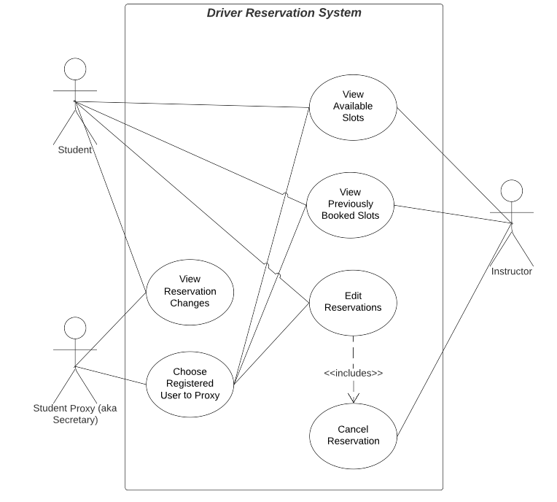

### UML Activity Diagrams

### UML Sequence Diagram

### UML Class Diagram

The classes that seem necessary at this time include:

- Abstract Class: User

- Derived Classes: Student and Instructor

- Vehicle

- Reservation

- Abstract Class: Instruction

- Derived Classes: Test and Lesson

## Technical Requirements

The technical specifications for a web-based Learning Management System (LMS) include:

- Deployment on a Linux-based web server utilizing Infrastructure as a Service (IAAS) on a third-party hosting site such as AWS or Google Cloud.

- A scalable architecture using Docker containers managed by Kubernetes.

- Development of APIs using RESTful design principles.

- Adoption of the SCORM standard for the LMS.

- Implementation of a hybrid encryption model using RSA-encrypted AES public keys.

- Encryption of all router traffic with TLS 1.2 or higher.

- Design compliance with Progressive Web App (PWA) standards.

- Compatibility testing of all web pages with iPhone 11 Pro on iOS 14.6.

- Compatibility testing of all web pages with Samsung Galaxy S10 on Android.

- Compatibility testing of all web pages with Chrome version 102.0.X.

- Establishment of a key performance indicator for uptime at no less than 99.5%.

- Specification that all report exports will be in CSV format.